*Project Documentation: Book Cover Design*

1. Introduction
1.1 Overview
- Provide an introduction to the project and explain the purpose of the book cover design.
1.2 Purpose
- Describe the main objectives and goals of creating this book cover.

2. problem definition & Design Thinking
empathy map
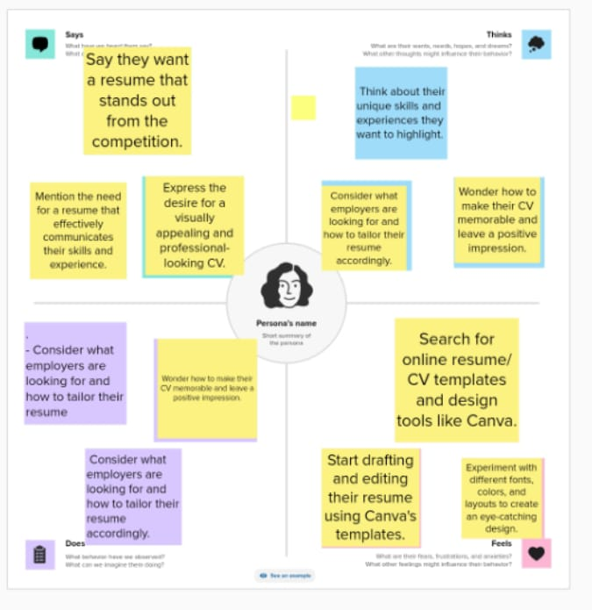

2.2 ideation & Brainstorming Map
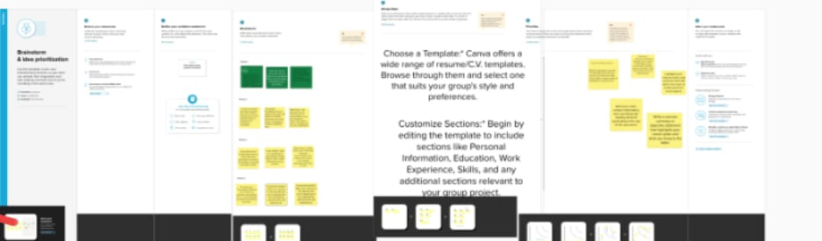

Result:


4.Advantages & Disadvantages*
- Discuss the pref and cons of the design choices made for the book cover. Consider factors such as target audience, aesthetics, and market impact.

5. Conclusion
- Summarize the key points discussed in the document and highlight the main takeaways from the book cover design project.

6. Future Scope
- Explore potential future improvements or iterations of the book cover, taking into account feedback and changing market trends.

7. Appendix
- Include any supplementary materials, such as design sketches, mock-ups, or additional research data that supports the project.

